**Database Management Systems Lab**

Lab CSL-220

Lab Journal: 5



Name: M.OMAR

Class: BCE-5

Enrollment No: 01-132182-024

**Lab # 5**

Introduction to Constrains operations on database

**Objective:**

Constraints in SQL

* NOT NULL Constraint
* DEFAULT Constraint
* UNIQUE Constraint
* PRIMARY Key
* FOREIGN Key
* CHECK Constraint
* INDEX

**Introduction:**

Constraints are the rules that we can apply on the type of data in a table. That is, we can specify the limit on the type of data that can be stored in a particular column in a table using constraints.

The available constraints in SQL are:

* **NOT NULL**:

This constraint tells that we cannot store a null value in a column. That is, if a column is specified as NOT NULL then we will not be able to store null in this particular column anymore.

* **UNIQUE**:

This constraint when specified with a column, tells that all the values in the column must be unique. That is, the values in any row of a column must not be repeated.

* **PRIMARY KEY**:

A primary key is a field which can uniquely identify each row in a table. And this constraint is used to specify a field in a table as primary key.

* **FOREIGN KEY**:

A Foreign key is a field which can uniquely identify each row in another table. And this constraint is used to specify a field as Foreign key.

* **CHECK**:

This constraint helps to validate the values of a column to meet a particular condition. That is, it helps to ensure that the value stored in a column meets a specific condition.

* **DEFAULT**:

This constraint specifies a default value for the column when no value is specified by the user.

**Dropping Constraints**

Any constraint that you have defined can be dropped using the ALTER TABLE command with the DROP CONSTRAINT option.

The basic syntax of an ALTER TABLE command to **DROP CONSTRAINT** from a table is as follows.

ALTER TABLE table_name

DROP CONSTRAINT MyUniqueConstraint;

The basic syntax of an ALTER TABLE command to DROP PRIMARY KEY constraint from a table is as follows.

ALTER TABLE table_name

DROP CONSTRAINT MyPrimaryKey;

**Integrity Constraints**

Integrity constraints are used to ensure accuracy and consistency of the data in a relational database. Data integrity is handled in a relational database through the concept of referential integrity.

There are many types of integrity constraints that play a role in **Referential Integrity (**RI**)**. These constraints include Primary Key, Foreign Key, Unique Constraints, and other constraints which are mentioned above.

**Tasks:**

1. Make the tables in Microsoft SSMS and add the constraints according to the following ER Diagram.

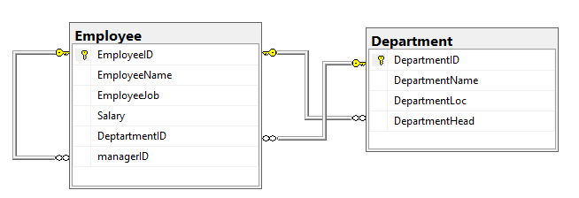

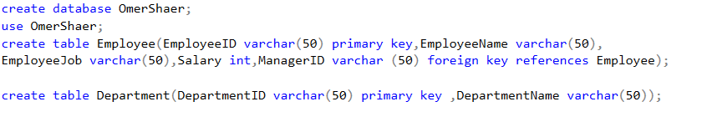**Output:**





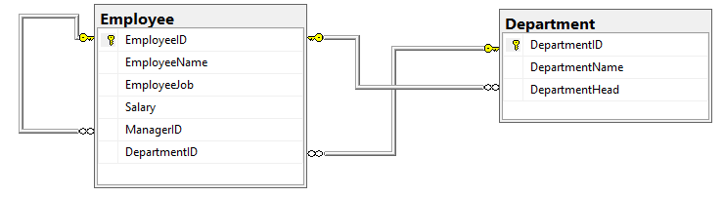

1. Primary and foreign keys in the tables should have the NOT NULL Constraint.

In your journal show all the queries of creation and alterations in the tables. And populate the tables with the data of at least 4 departments and 10 employees.

**Output:3**

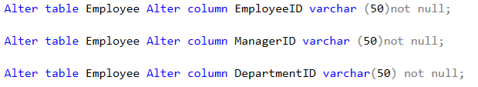



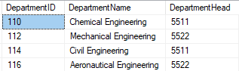



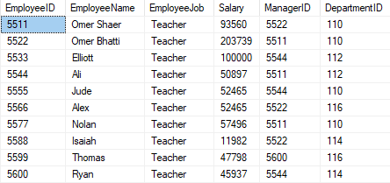

**Conclusion:**

In this lab we learned about NOT NULL Constraint DEFAULT Constraint UNIQUE Constraint PRIMARY Key FOREIGN Key CHECK Constraint INDEX on database